**Exercise 2 Specialized Text Tags**

**Objectives:** Practice using specialized text tags including <small>, <abbr>, <q>, <cite>, <dfn>, <sub>, and <sup>.

**Requirements:**

* Create an HTML document with proper structure
* Include at least three different specialized tags
* Create content that appropriately uses each tag
* Add comments explaining each tag's purpose

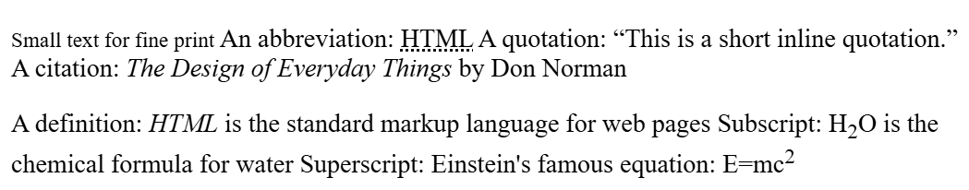

Small text for fine print An abbreviation: HTML HyperText Markup Language A quotation: This is a short inline quotation. A citation: The Design of Everyday Things by Don Norman

A definition: HTML is the standard markup language for web pages Subscript: H2O is the chemical formula for water Superscript: Einstein's famous equation: E=mc2